Henan Deyirui New Material Co., LTD
Items  Product Name |  | Chromatic light | Strength  (%) | moisture content（%） | pH value | Iron ion content（ppm） | Conductivity  （µs/cm） | External standard  (%) | DMF insolubles  （%） | Ash content（%） | Pressure value  (MPa) | Use
General products | Iindex | Approximate, micro | ≥460 | ≤0.5 | 5.0-7.0 | ≤10 | ≤50 | ≥99.0 | ≤0.15 | ≤0.2 | Be without | Filter cake, plastic, color masterbatch
General products | Random measurement | Approximate, micro | 460 | 0.05 | 5.16 | 6.69 | 35.1 | 99.27 | 0.08 | 0.11 | Be without | Filter cake, plastic, color masterbatch
Fine products | Iindex | Approximate, micro | ≥460 | ≤0.5 | 6.0-8.0 | ≤10 | ≤30 | ≥99.5 | ≤0.1 | ≤0.1 | Be without | Ink, inkjet, digital printing, high end color masterbatch (medicine, aviation)
Fine products | Random measurement | Approximate, micro | 460 | 0.03 | 6.23 | 5.36 | 25 | 99.59 | 0.02 | 0.02 | Be without
Excellent products | Iindex | Approximate, micro | ≥460 | ≤0.5 | 6.0-8.0 | ≤10 | ≤20 | ≥99.5 | ≤0.1 | ≤0.1 | 0.2 | wire drawing
Excellent products | Random measurement | Approximate, micro | 460 | 0.01 | 6.21 | 3.28 | 18 | 99.65 | 0.01 | 0.02 | 0.04 | wire drawing
Specific Product Description (Solvent Yellow 114)

产品描述（溶剂黄114）Product Description (Solvent Yellow 114)

溶剂黄114 (Solvent Yellow 114)
分子式 (Molecular Formula): C18H11NO3 分子量 (Molecular Weight): 289.289
CAS NO: 75216-45-4 EINECS NO: 231-474-9
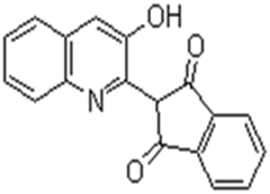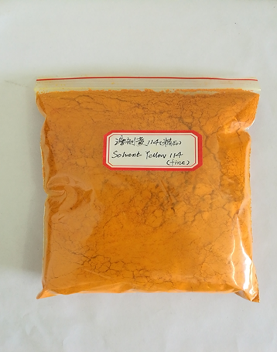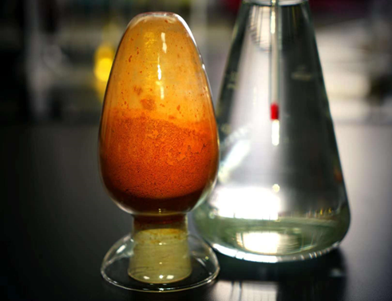

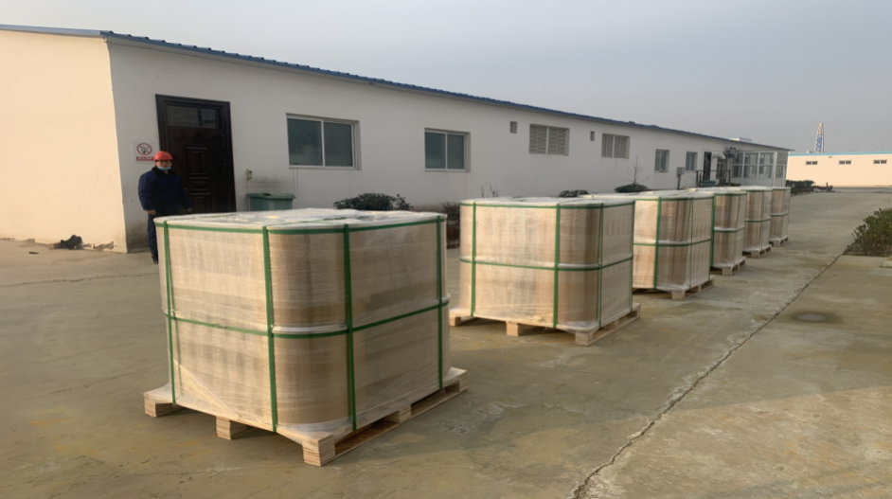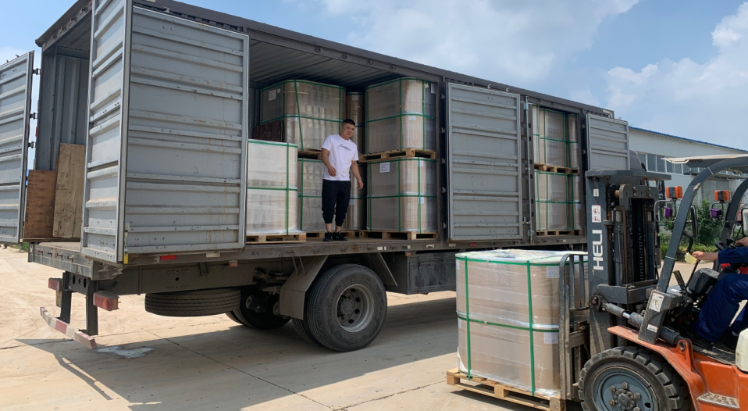

检测项目  Items  产品名称  Product Name |  | 色光  Chromatic light | 强度  Strength  (%) | 水分  moisture content（%） | PH值  pH value | 铁离子  Iron ion content（ppm） | 电导率  Conductivity  （µs/cm） | 外标  External standard  (%) | DMF不溶物  DMF insolubles  （%） | 灰分 Ash content（%） | 压力值  Pressure value  (MPa) | 用 途  Use
普品  General products | 指标  Iindex | 近似、微  Approximate, micro | ≥460 | ≤0.5 | 5.0-7.0 | ≤10 | ≤50 | ≥99.0 | ≤0.15 | ≤0.2 | 无  Be without | 滤饼、塑料塑胶、  色母料  Filter cake, plastic, color masterbatch
普品  General products | 随机实测Random measurement | 近似、微  Approximate, micro | 460 | 0.05 | 5.16 | 6.69 | 35.1 | 99.27 | 0.08 | 0.11 | 无  Be without | 滤饼、塑料塑胶、  色母料  Filter cake, plastic, color masterbatch
精品  Fine products | 指标  Iindex | 近似、微  Approximate, micro | ≥460 | ≤0.5 | 6.0-8.0 | ≤10 | ≤30 | ≥99.5 | ≤0.1 | ≤0.1 | 无  Be without | 墨水、喷墨、数码印花、高端色母（医用、航空）Ink, inkjet, digital printing, high end color masterbatch (medicine, aviation)
精品  Fine products | 随机实测Random measurement | 近似、微  Approximate, micro | 460 | 0.03 | 6.23 | 5.36 | 25 | 99.59 | 0.02 | 0.02 | 无  Be without
优品Excellent products | 指标  Iindex | 近似、微  Approximate, micro | ≥460 | ≤0.5 | 6.0-8.0 | ≤10 | ≤20 | ≥99.5 | ≤0.1 | ≤0.1 | 0.2 | 拉丝  wire drawing
优品Excellent products | 随机实测Random measurement | 近似、微  Approximate, micro | 460 | 0.01 | 6.21 | 3.28 | 18 | 99.65 | 0.01 | 0.02 | 0.04 | 拉丝  wire drawing

