
ETON FOOD CO., LTD
JIXI ROAD, JISUO TOWN, TENGZHOU CITY,
SHANDONG PROVINCE, 277518 P.R. CHINA

Certificate of Analysis
Report date: 2021.08.20
Name of Sample | Calcium Propionate |  | Quantity |  | 19000kg
Mfg. Date | 2021.08.20 |  | Batch No. |  | 20210820
Exp. Date | 2023.08.19 |  | Complies With |  | FCCIV
Result of Analysis
Parameter |  | Standard |  | Test
Appearances |  | White crystalline powder |  | confirmed
Particle size |  | 40-80 mesh |  | confirmed
PH (1:10 aqueous solution) |  | 7.5~10.5 |  | 8.2
Assay (dry basis),% |  | 98.0~100.5 |  | 99.6
Insoluble Substances,% |  | ≤0.2 |  | <0.2
Water (loss on drying),% |  | ≤5.0 |  | 4.8
Fluoride (as F), ppm |  | ≤30 |  | <30
Magnesium(asMgO) |  | Passed test |  | Passed test
Lead , ppm |  | ≤2 |  | <2
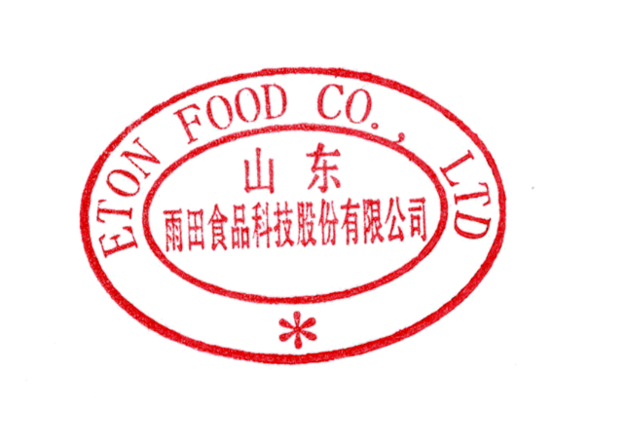
Conclusion：Confirmed Standard.
Analyzer: Zhang Xiaohong Checker: Ma Qinchang Quality Control Seal:

