Hydroxytyrosol the Future of Health
What Hydroxytyrosol Is:
Hydroxytyrosol is an antioxidative natural product found in olives. It is a phytochemical belonging to the family of polyphenols. Olive oil application has a rich and extensive history in the Western hemisphere. A popular form of olive oil application is the Mediterranean diet. This diet was ranked the number one diet by the U.S. News and World Report. It is partially so beneficial because of the hydroxytyrosol content found in the olives. Application of this antioxidant was approved by both the USA and the European Union. The European Commission Database for Cosmetic Substances and Ingredients concluded that use of hydroxytyrosol is safe under the proposed uses and use levels.
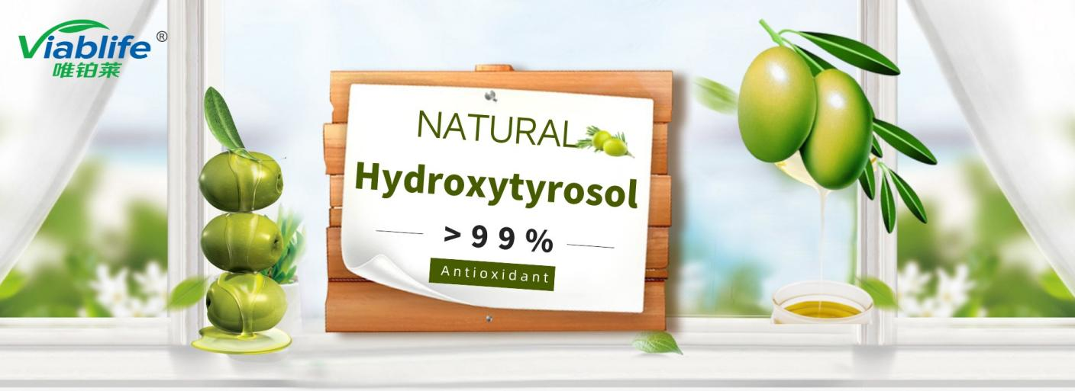

Benefits of Hydroxytyrosol:
- Hydroxytyrosol is currently the most powerful natural antioxidant ingredient. Studies show that hydroxystyrosol's antioxidant capacity is 2 times greater than resveratrol and 20 times greater than vitamin C.
- Hydroxytyrosol protects skin from UV radiation. Hydroxytyrosol prevents UV radiation damage that may cause melanoma and other skin cancers. This is because hydroxytyrosol reduces the breakdown of DNA strands caused by UVB radiation.
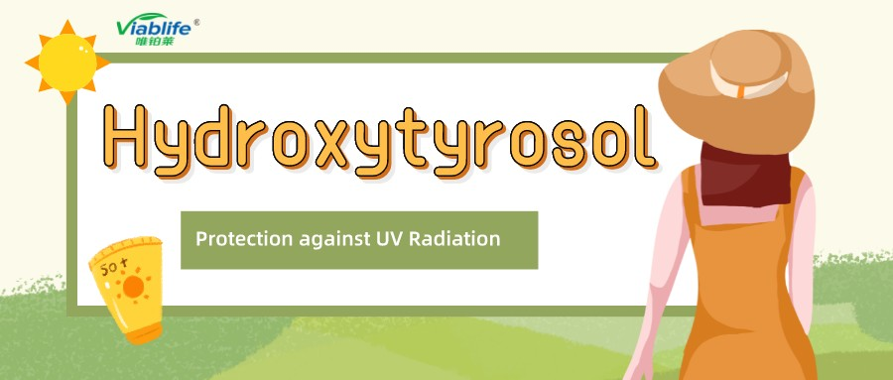
- Hydroxytyrosol improves skin condition and provides for anti-aging functions. Hydroxytyrosol can effectively improve one's skin and keep said skin moisturized for a long period. Studies regarding this molecule demonstrate that it has promising anti-aging properties. An example of these properties is its ability to erase wrinkles. Hydroxytyrosol also restores skin damage and allows for the regeneration of new skin.
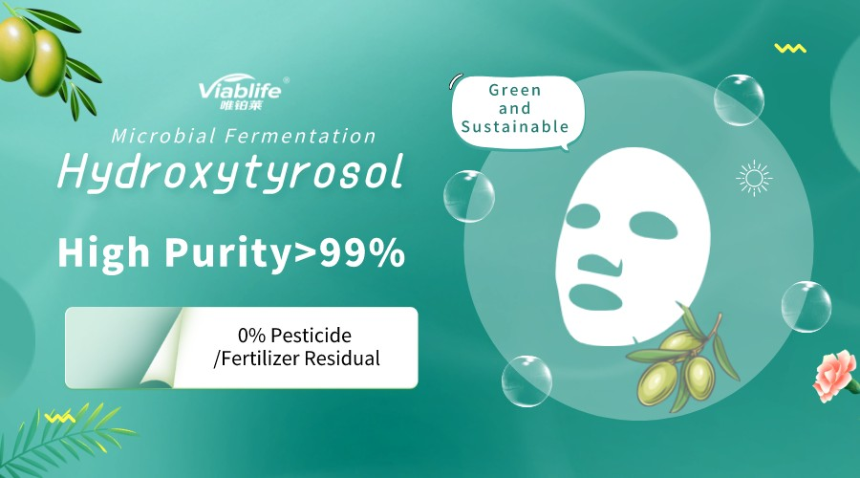
- Hydroxytyrosol's antibacterial traits allow for prevention and protection against numerous diseases. Low concentrations of hydroxytyrosol can prevent/protect against the following diseases and infections: neuro-degeneration diseases, inflammation, Typhia, Enteritidis, Cholera, pyogenic infection, age-related macular degeneration, and cardiovascular diseases such as respiratory infection. Not only does hydroxytyrosol protect/prevent the above diseases and infections, but it also does this at lower concentrations than other antioxidant options.
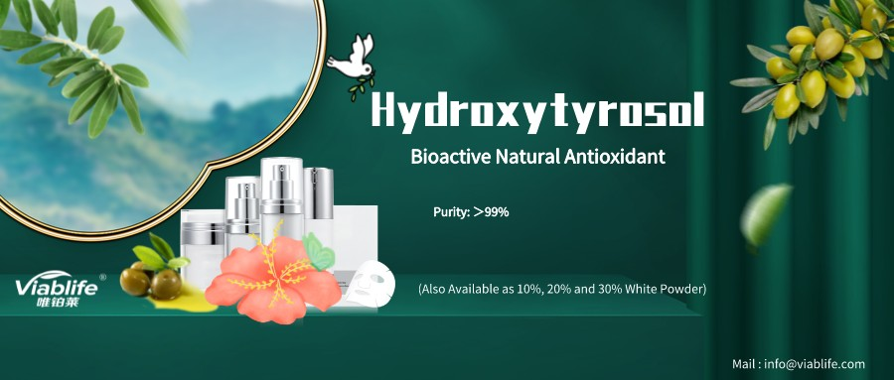
Why Choose Viablife Hydroxytyrosol:
Viablife has a world-class research and development team that has a wide range of experience in fermentation, enzymes, metabolic engineering, and synthetic biology. Viablife is currently the only manufacturer who can provide commercial scale >99% purity hydroxytyrosol. Unlike plant-extracted hydroxytyrosol, Viablife's hydroxytyrosol does not contain any residual pesticide or fertilizer, making our product safer and healthier. The high purity and quality of Viablife Hydroxytyrosol provides for perfect applications in cosmetic, food/supplemental, and pharmaceutical products.

Please email us at info@viablife.com or visit https://en.viablife.com/ to learn more if you are interested in the most antioxidative ingredient--Hydroxytyrosol!

